**PROJECT 420, Lesson 3: Cost Estimating Fundamentals**

**Lesson 3: Cost Estimating Fundamentals**

**Reading Assignment**

**Objectives**

After mastering the material in this lesson, you will be able to

* describe the advantages and drawbacks of top-down and bottom-up budgeting;
* explain the importance of learning-curve analysis to project management;
* distinguish between direct and indirect costs, and allocate particular costs to the appropriate category;
* describe the cost estimating used in your workplace as top-down, bottom-up, or negotiation-in-action;
* decide on indirect costs to be included in a hypothetical cost estimate;
* review a cost estimate for potential errors; and
* write a complete cost estimate report.

**Activity Preview**

**Overview**

* Do you feel nervous when someone mentions the term *cost estimating?* Many managers *are* nervous about cost estimating—and why shouldn't they be? Junior managers may significantly pad their cost estimates, knowing higher-level managers will take a percentage off anyway. Senior managers, knowing junior managers do pad their estimates, may take an even bigger percentage off the junior manager's estimate. A vicious cycle can turn on as the estimator and the manager try to come to a realistic number by outguessing each other. You've learned about the dangers of padding in activity estimates—but here, things get really touchy.
* Even though this kind of "game playing" does go on, individuals who are consistently honest gain credibility and their estimates are accepted more often. In this lesson, we will discuss inputs to cost estimating and various methods for conducting cost estimates. You will also learn about strategies for obtaining the most accurate estimate possible, as well as for having your estimate accepted by senior managers. In the next Lesson, we will discuss cost budgeting and how you will establish a cost baseline for a project.
* *Note: Some of the material in this lesson has been adapted from chapter 7 of* Project Management: a Managerial Approach *by Jack R. Meredith and Samuel J. Mantel, Jr. (John Wiley & Sons, Inc., 1995)*

**Building on What You Know about the Planning Process**

Up to this point, you have been learning how to identify project activities, estimate durations for the activities, and create a schedule composed of the activities. Another part of your overall project planning is first estimating, then budgeting costs for each activity. To do this, you will return to that essential planning document—you guessed it!—the work breakdown structure (WBS). As you already know, cost estimation is a critical part of understanding the overall picture of resources for your project, and is therefore a large piece of your overall project plan.

**What Role Does Cost Estimating Play in the Project Management Process?**

*Cost estimating* is an essential activity for building a project budget. Until you have an idea of what individual work tasks will cost, it is impossible to obtain a figure for the overall project cost. You need to begin with the planning tool that shows a breakdown of project activities into lowest-level work tasks: the WBS. You want a cost breakdown structure that corresponds with the WBS.

You'll find that preparing cost estimates for a project usually requires the cooperation of several people. If you work for a firm that regularly submits bids, you may have professional cost estimators on staff. In this case, it will usually be the project manager's job to provide a description of the project work, with enough detail that the estimator can figure out how much and what kind of data needs to be collected. Most likely, the project will be too complex for the project manager to come up with this information without seeking help from experts in the relevant areas.

**Abbreviations**

* WBS (work breakdown structure)
* R&D (research and development)
* BLS (Bureau of Labor Statistics)

Project managers collecting estimates for direct costs find it helpful to use a form that lists the level of resources needed and shows when a resource is needed. The result is a preliminary schedule. The project manager can then note if the resource will be available at the appropriate time. Figure 3.1: Direct Costs Form shows one such form.

**Figure 3.1—Direct Costs Form**

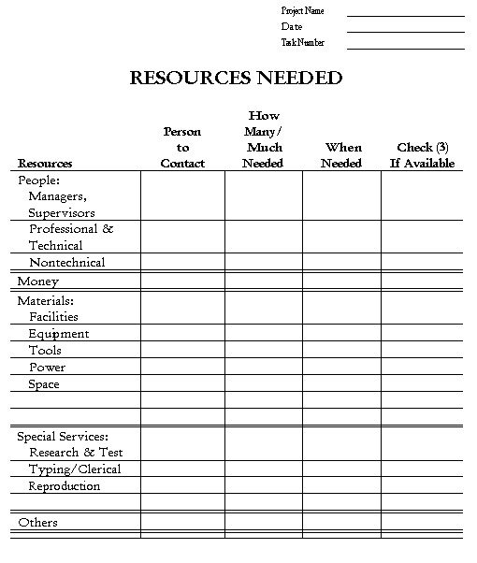

You can use this form to collect resource requirements for individual work tasks in a project, or to aggregate the data from a number of work tasks onto a single form. You'll note that the form does not contain information on overhead costs; the composition and amount of overhead costs to be added to project overall costs are unique to each organization. Personal wages and salaries are not the normal charging rates. Overhead charges get added to wages and salaries. These overhead costs are generally beyond a project manager's control, and they are usually a source of aggravation for everyone concerned. The allocation of overhead tends to be arbitrary, and can sometimes make an otherwise-attractive project look unfeasible. While some overhead costs such as payroll burden, office rent, and maintenance costs are relatively stable, other overhead costs, such as litigation and moving expenses may fluctuate significantly from month to month or even year to year. Overhead costs are a reality you will simply have to deal with.

A way to protect your project, is to estimate the number of labor-hours that your project needs. Then, commit to that number. Overhead rates can change arbitrarily as they sometimes do. You do not have to manage against floating numbers. You can manage against stable numbers.

**Developing a Project Budget in** *Your* **Organization: What Is a Budget, Anyway?**

A budget is an expression of a project plan in monetary terms. It describes where money will be allocated: for which activities and over how much time. It is a realistic forecast of all the resources that will need to be allocated to complete the project. A project budget is equivalent to the project plan, just in another form.

Developing a project budget involves identifying and estimating the following:

* The resources the project requires.
* The required quantity of each resource.
* When the resources will be needed.
* How much the resources will cost (factoring in cost escalation over the time period of the project).

If you work for an established organization that has been doing projects for some time, you will probably find cost-estimation methods have been codified to some degree. Purchasing departments are often little libraries in themselves, filled with price catalogs for materials, machines, or services, as well as books describing estimating techniques for materials and labor for specific tasks. Most businesses have their own methods of estimating costs. The methods are usually based on years of experience.

That said, remember that developing budgets for projects is much more difficult than developing budgets for more permanent types of activities (programs). As you know, a project is unique (and therefore has unique budgeting requirements) while a program is not. Although you *can* use past projects as a basis for your estimates, these will only be rough guides. Jack R. Meredith and Samuel J. Mantel have the following encouraging words to say about patterns of project budgeting over time, however:

"Tradition, however, has another impact on budgeting, this time a helpful one. In the special case of R&D [research and development] projects, it has been found that project budgets are stable over time when measured as a percent of the total allocation to R&D from the parent firm, though within the project the budget may be reallocated among activities. There is no reason to believe that the situation is different for other kinds of projects, and we have some evidence that shows stability similar to R&D projects." (From *Project Management: A Managerial Approach* by Jack R. Meredith and Samuel J. Mantel, Jr. John Wiley & Sons, Inc., 1995, pp. 290–291.)

In addition, every organization uses a different accounting system. For example, one firm might charge certain kinds of employee training to a project's R&D budget, while another organization might not charge employee training to a project at all. The project manager *must* understand the organization's accounting system in order to have control over the project from a budgetary standpoint.

**Tips for Dealing with Organizational Factors**

In dealing with the organization's accounting department, keep in mind that accounting is likely to allocate an even pattern of resource use over a given period of time, unless the pattern of expenditures is noted in the project plan. It is important that every expenditure be identified with a project task and its associated milestone (deliverable). Each item in the WBS should have a unique account number by which charges can be accrued as work is accomplished. This system is necessary if the project manager is to have control over the budget.

Notice that word: *control.* Often, other people (usually senior management) decide the dollar amounts allocated to different activities. Although project costs may be viewed differently by different people with varying agendas, it is up to senior management to accept responsibility for these assignments. Therefore, the control that the project manager has, is over the timing and amounts of expenditures (within the given constraints) once the budget is approved and the project is underway. Later in this lesson, we will look at methods of cost estimating. You will see how hard it can be for the project manager to influence the final budget.

**Growth Opportunities**

Sometimes, the senior management of an organization will decide to fund projects that may lose money but that provide the organization with growth opportunities. These may include incentives such as the following:

* Increasing knowledge of technology.
* Opening up development in a completely new area.
* Getting additional business down the road that would more than pay for the initial investment.
* Improving the organization's reputation in a particular area.
* Expanding on a product line.

These kinds of projects are viewed as "investments"; they are not typical of most projects you will work on. They are the type that you will be told to proceed with even though you do not see a fruitful outcome.

**Cost Estimating: A Definition**

**Inputs to Cost Estimating**

Key inputs to the cost estimating process include:

* the WBS
* a list of resource requirements
* a list of resource rates
* activity duration estimates
* historical information

A *cost estimate* is the sum of costs for the various aspects or parts of a project.

* For a contractor, this is the cost of completing the project as defined by the contract terms, the product of which is then turned over to the owner. The contractor's cost consists of its internal costs plus those charged by its subcontractors, suppliers, and any other parties.
* The owner's costs are the costs for administering the project, the costs that the contractor(s) charge the owner, and the costs incurred for the owner's consultants, engineers, and suppliers.

Other things that may need to be included in an organization's estimate are the costs of land, provisions for interim and permanent financing, and various elements of life-cycle cost associated with ownership and operation. Detailed cost estimates are expected to be accurate within plus-15 or minus-5 percent, but vary depending on industry. Cost estimates are also figured for individual work tasks. The PMBOK describes cost estimating as "Estimating the cost of the resources needed to complete project activities."

I agree with Lewis that the best way to obtain a realistic cost estimate is to develop an average expected duration based on similar, previous work. This is why labor reports are so important. They assume that personnel assigned to do the work have a certain skill level. You will need to make adjustments if you will be working with a higher or lower level of employee skill. Note what Lewis says about how experience and speed of task completion are not directly correlated.

If there is no historical basis for obtaining an estimate for a particular task, it might be best to use the "three-point" technique as EPM describes. Additionally, you may work in an industry (such as construction) for which there are published tables of expected durations. Other than that, all I can tell you to do is to keep records of the time it takes to complete specific tasks, and make your records as accurate as possible! This can be especially important when "volunteers" are the people resources for an annual project. Although you do not pay the volunteers, you still need to be able to size the project next time - or if the project will be copied somewhere else.

The process of estimating is accomplished in the following steps:

**Key Terms**

* take-off
* costing
* pricing

1. ***Take-off***—measuring the quantities of work and cataloging cost items derived from the scope documents (work to be done to create the deliverables).
2. ***Costing***—using the take-off and information presented in the deliverables' specification documents to assign cost values to the elements of work and other related items in the project or endeavor.
3. ***Pricing***—determining the amount to be charged the client (whether lump sum or unit-price) so as to fully include direct and indirect cost items—and to provide a profit and cover possible contingencies (total cost = value).

**Direct and Indirect Cost Items**

For most projects, you will be dealing with four major cost categories:

* Labor
* Materials
* Other direct costs (e.g., travel, communications, services)
* Indirect costs (e.g., overhead)

Sometimes, indirect costs are calculated as a fixed percentage of total project direct costs. This is usually done with such "unallocatable" costs as utility charges, property depreciation, and overhead, because indirect costs have to be recalculated whenever changes occur at lower levels of the project. It's a good idea to charge indirect costs to the highest level that makes sense—which may or may not be at the project level. With large projects, it is often at a lower level; your own common sense will be your best guide here.

Because many estimates are based upon historical data (that is, data compiled from previous projects) it is especially important to keep direct and indirect costs separate in an estimate. The less direct-cost data is cluttered with indirect costs, the more reliable it will be to use with the new project. By keeping indirect costs separate, you'll also be able to more accurately account for the unique conditions you encounter in the new project. That separation enables you to make a clean estimate of the resource required (e.g., labor hours).

**Elements of Equipment, Labor, and Materials Costs**

Figure 3.2, below, shows a hierarchical chart of a construction cost estimate. Cost estimates for other types of projects will probably take a similar form, but may include different costs or a different arrangement of costs—some more or some less—than this construction cost estimate.

**Figure 3.2**—**Components of a Cost Estimate**

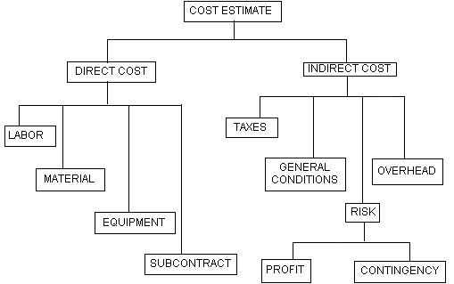

**Direct Costs**

**Key Terms**

* direct costs

***Direct costs*** shown in figure 3.2 include labor costs, material costs, equipment costs, and subcontract costs.

* **Labor Costs**—the total of the amounts paid to personnel who perform work on the project (such as carpenters, painters, and electricians). Labor costs can be broken into two parts:
  + the basic wage (wage rate times the number of hours worked); and
  + the "labor burden," including such items as taxes and insurance (which employers are required to pay), as well as any fringe benefits previously agreed upon.

**A Note about "Line Item" Costs**

Line item costs are those costs related to the lowest-level tasks in the project WBS—that is, the lowest level useful for measuring and controlling. For example, if you're going to put up a certain amount of drywall as a part of a large shopping mall project, it's not particularly helpful to create a line item for screws. Instead, create a line-item category called "miscellaneous fastenings."

The labor burden portion of the total labor cost is not always treated as a direct cost element, because it is not usually directly proportional to hours worked. In most cases, treat the labor burden according to your company's practice, unless the contract conditions specify otherwise.

* **Materials Costs**—the prices of materials or parts used on a project. Sometimes these prices are solicited from manufacturers and suppliers; in other cases, manufacturers and suppliers circulate prices to contractors they know will be working on a specific project (a is one way to do this). Usually, these prices are specific to the types of material used, within a given period of time, and at a specified location. Most contractors include delivery charges as part of direct costs, and taxes as part of indirect costs.
* **Equipment Costs**—the cost of equipment a contractor uses to fulfill a contract (for example, cranes or bulldozers). This does not include equipment installed permanently as part of a contract (e.g., autoclaves, window washing equipment). If the equipment is leased, the cost consists of lease costs and cost of fuel. If the equipment is owned by a contractor, those costs include owning costs (e.g., investment, insurance, depreciation) and operating costs (e.g., fuel, maintenance, repairs). Most contractors include the costs of operators for operating equipment, in the direct labor costs, even though they are part of the operating costs.
* **Subcontract Costs**—the cost of services provided by subcontractors for completing work on a specific portion of a given project that the general contractor does not perform with his or her own personnel.

**Indirect Costs**

***Indirect costs*** include taxes, ***general conditions***, risk elements, and overhead.

**Key Terms**

* indirect costs
* general conditions
* **Taxes**—usually cataloged separately to facilitate accounting, because taxes vary significantly from location to location and by owner's tax-exempt status.
* **General Conditions**—the cost of items or conditions that must be provided to enable work to be performed on a given contract. Often, these items cannot be charged to any particular element of the work. General conditions include supervision, office trailers, toilets, permits, photographs, certain tools, and cleanup activities.
* **Risk Elements**—include two categories: profit and contingency.
  + **Profit**—the amount of money included by a contractor in the overall estimate as compensation for the risk, effort, and endeavor required to undertake a project. This amount is subjective, and varies from case to case. The actual amount usually depends on considerations such as competition, the job market, local conditions, and the economy.
  + **Contingency—** In cost estimating, a contingency mark-up is added, based on subjective reasoning and/or structured risk analysis. This is because estimates are based on assumed values of cost and productivity that are subject to variability. In addition, other risk items such as weather or labor problems could affect the project. Therefore, actual costs can be either higher or lower than the estimate; in most cases, they turn out to be higher. As you learned with duration estimating, however, simply padding your estimates (beyond a reasonable contingency) is not the answer to assessing contingency costs.

**Overhead**

***Overhead*** costs for this example also fall into one of two categories: main office overhead and job overhead.

**Key Terms**

* overhead
* **Main office overhead**—includes the fixed costs and expenses incurred by a company in the course of doing business, regardless of the amount of work completed or contracts received. These costs and expenses include main-office rent or lease, utilities, communication (e.g., telephone), advertising, salaries of main-office employees (e.g., estimators, secretaries), salaries of executives, donations, legal costs, accounting expense, and so on, which are not chargeable to any specific project.

One method of calculating main office overhead is to use a percentage of the total annual main office overhead costs, with percentage calculated as a ratio of this specific project's total cost to the entire company/division's annual project costs.

* **Job overhead**—another name for general conditions or job indirect costs. This includes costs incurred at the job level in performing a specific contract, but not chargeable to any specific item of that contract.

**Top-Down Cost Estimating**

**Important**

* See some of the [**pros and cons of top-down and bottom-up estimating**](http://moodle.extn.washington.edu/mod/page/view.php?id=139751).

*Top-down cost estimating* is a method that involves collecting information from top and middle managers and from historical data (documentation on similar projects conducted in the past). The top managers estimate overall project cost and the cost of major sub-projects. Lower-level managers then continue the cost breakdowns for specific tasks and work packages. The estimating procedure parallels the process of creating the WBS.

With top-down budgeting, junior managers often feel forced to accept the senior managers' budgets, even when the junior managers believe insufficient funds have been allocated toward the objectives to which the junior managers must commit. The advantage of this type of budgeting, however, is that *overall* budgets are often estimated extremely accurately, even if allocations for individual items are not completely accurate.

Top-down cost estimating assumes senior management's judgment and experience factors in all elements that need to be considered. This, unfortunately, is not always the case. I remember once setting a $5,000,000 budget estimate early in the design phase that included a 10 percent contingency to account for scope anticipated but not yet identified. Senior management felt otherwise—that the scope was well defined—and therefore adjusted the budget to $4,500,000. Unfortunately, the estimate was never validated during the rest of the design process, and by the time the low bid of $4,980,000 was received, it was too late.

A certain amount of padding is necessary, but it must be clearly identified and done on a task-by-task basis. A realistic amount of padding is necessary to provide for contingencies. Too much padding can cause the project to go over budget or not be approved at all.

Some contractors will deliberately underbid a project -particularly if the specifications are weak. Change orders charged at regular rates can help recover from the underbid.

**Bottom-Up Cost Estimating**

**Key Terms**

* bottom-up cost estimating

In ***bottom-up cost estimating***, the project WBS is again employed so costs can be estimated for each individual activity. The difference this time is that the individuals who are actually doing the work are consulted regarding times and costs associated with each work task, to ensure the greatest accuracy. This approach can also result in superior commitment and dedication. Personal names are "on the line". In the previous example, ("Top-Down Cost Estimating") mechanical costs were budgeted on a cost-per-square-foot basis; additional detail at a lower level would reduce the need for contingency while providing an adequate budget. This means conducting cost estimates from lowest-level activities on up. Estimates are initially made in terms of resources, such as materials and labor hours; later, they are converted to dollars. As with top-down estimating, there may be differences of opinion between junior and senior managers. Sometimes a project manager will also want to talk to a functional manager, to improve the accuracy of the estimates. The smaller work-task estimates are ultimately compiled to yield overall project costs. They come from rolling up the Cost Breakdown Structure. The project manager will usually add certain indirect costs, such as administrative costs, a contingency reserve, and a profit figure.

**Participative Management in Cost Estimating—Negotiation in Action**

Can you think of times when a senior manager asked for your input on a planning process that governed work you routinely did? Did being included in the planning process give you a feeling of empowerment? The thinking behind participative management is that employee motivation and accountability increase when the design or planning of a task is allocated to the individual who will actually complete the work. Participative management can, however, entail a complex series of planning sessions between the individual and his or her manager as time and cost estimates are continually adjusted.

**Reconciling Estimates that Come from Different Perspectives**

**Key Terms**

* negotiation in action

With participative management, the manager estimates costs for the highest level of the WBS, and the team member estimates costs for the lowest level. From there the ***negotiation-in-action*** begins. Most likely, from the manager's perspective, the team member's estimate for a work task will seem too great a percentage of the higher-level estimate developed by the manager. In fact, it is commonly true that the higher up a person is on the organization chart, and the farther away from immediate responsibility for doing the work, the more likely he or she thinks the task can be done more easily, more cheaply, and faster than estimated by the person who actually performs the task. The manager may also wish to underestimate time because he or she

1. wishes to impress senior management, or
2. figures the team member will add too much padding.

On the other hand, the team member may, in fact, add padding on top of an estimate that *already* has contingency padding.

Assuming the manager and the team member desire to work honestly with one another, they will meet and go over each other's figures. This results in the team member educating the manager about the job and its complexities, and the manager's estimates being revised upward. Typically, this makes team member feel good, and encourages him or her to drop some of the extra padding in the estimate. The two individuals will then work together to practice principles of quality management, and go over the team member's work plan to try to find ways to increase efficiency; perhaps they can make some changes that require fewer resources. At a certain point, it will appear that no further improvement is possible. What happens when some improvement has been made but the manager's and team member's figures are still out of balance?

**Hint: Consider the Project Life Cycle**

At this point, we return to concepts of the project life cycle for an answer. Many kinds of projects follow the life cycle shown in figure 3.3, below.

**Figure 3.3—One Possible Shape for a Project Life Cycle**

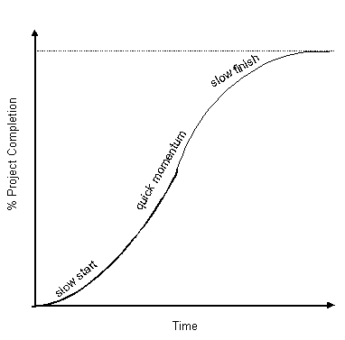

These projects—construction projects, for example—begin slowly, gain a quick momentum, then move to a slow finish. The construction project life cycle does not necessarily represent other types of projects, however. Many types of projects maintain a much slower momentum until later stages, when successive inputs of time or resources result in increasingly greater increments of completion. The life-cycle diagram for this type of project would look like the one shown in figure 3.4, below.

**Figure 3.4—Another Possible Shape for a Project Life Cycle**

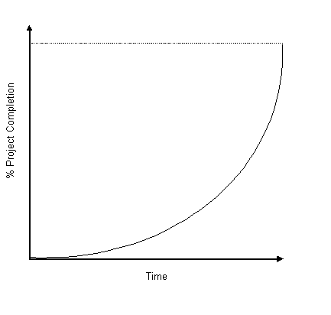

Projects that follow this kind of life cycle—for example, development of computer software or a publication—are those for which output is constructed on a number of subunits or sub-programs that are finally put together to create the finished product. When the subparts come together, the completion rate rises rapidly.

For a project with a life cycle like that shown in figure 3.3, continued inputs of time and resources result in smaller and smaller increments of completion. For projects with a life cycle like that shown in figure 3.4, however, the situation is just the opposite. In the negotiations between the manager and the team member that we've been discussing, the cost estimates will probably not be too far out of proportion. To decide whether to adopt the team member's estimate or the manager's, you need to know which life cycle represents the task under consideration. It is not important to know the precise shape of the life cycle; you just need to know whether it has the S-shape shown in figure 3.3 or the concave shape shown in figure 3.4.

If the latter part of the life cycle curve is S-shaped, it's wise to opt for the manager's estimate because of the relatively small impact the estimate will have on final completion (i.e., resulting from withholding a small amount of resources). If the life-cycle curve is concave, however, choose the team member's estimate, because of the possibly-disastrous effect of a shortage of resources on final project completion.

**Learning Curves**

**Key Terms**

* learning curve

Depending on what type of project you are doing and whether or not your organization has done similar projects in the past, ***learning curves*** may or may not significantly affect your cost estimates. Direct labor costs are especially difficult to estimate if the firm is not familiar with the project work. You will need more time per work task or "deliverable" early in the production process, but you will find worker performance improves with each repetition of a task. The learning rate is the percentage worker hours per unit decrease each time the overall work output doubles (as a direct result of increased worker experience with the task); a worker who takes 10 minutes to accomplish a task done for the first time, then takes 8 minutes the second time, has an 80% learning rate. If you fail to take the learning rate into consideration on projects where there will be high labor costs, you can significantly overestimate the cost of a project over its duration.

Figure 3.5, below, shows limited learning to an optimum level. The average level of effort, therefore, will only be maximized through large quantities of output.

**Figure 3.5—Limited Learning to Optimum Level**

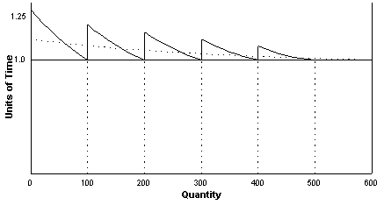

Figure 3.6, below, shows remembered learning, which can be optimized much more quickly.

**Figure 3.6—Remembered Learning to Optimum Level**

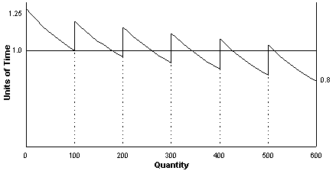

If you can dedicate resources and constantly apply them, as in figure 3.7, below, you can achieve additional "profit" through extended productivity.

**Figure 3.7—Resources Dedicated and Constantly Applied**

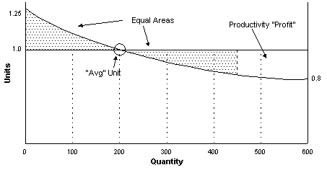

**Parametric Estimating**

Parametric estimating as a technique is discussed in the PMBOK. It is defined in the PMBOK's glossary as "an estimating technique that uses a statistical relationship between historical data and other variables (e.g., square footage in construction, lines of code in software development) to calculate an estimate for activity parameters, such as *scope*, *cost*, and *duration*." The way parametric estimating is used varies by industry and by project.

**When Things Go Wrong**

The project manager is nothing if not brave! The unfortunate reality is there is almost no end to the number of things that can cause errors in cost estimates. We will discuss some of the problems that occur most often.

**Changes in Resource Costs**

Many organizations respond to this problem by modifying all cost estimates by a fixed percentage. An even more useful method is to identify each input that represents a substantial part of project cost and estimate the direction and rate of price change for each input.

Here's an example. Let's say we have a project budget of $1 million, to be spent in equal amounts yearly over a three-year period. If we think materials costs will comprise about 40 percent of the total, also allocated equally across the three years, the bill for materials will be about $400,000. Dividing that across the three years, we have expenditures of $133,333 per year. If we obtain information that indicates costs for these materials will increase by 6 percent per year, our materials expense for the second year increases to $141,333 (an increase of $8,000). These costs will subsequently increase to $149,813 in the third year (an increase of $8,480). If we neglect to account for this escalation, we'll find we have underestimated the cost of our project by about $16,500. This error represents slightly more than 4 percent of the total material cost and almost 2 percent of the total project budget.

You should also be aware that different inputs will rise or fall at different rates during the same time period. The Bureau of Labor Statistics (BLS) puts out wage and price indices, which cover a great number of wage rates for specific commodities. As a project manager, you might want to use different inflators for different classes of labor or types of commodities.

Part of preventing mistakes includes knowing your organization's willingness to tolerate error. Let's say that in your organization, management is willing to accept a 5-percent difference between actual and estimated cost for each major input category. In the example of materials costs we used earlier in this section, expected increases in the materials cost category use more than four-fifths of that allowance. This leaves less than 1 percent (about $3,500) of allowable error—not much, if it turns out you need to add a structure or demolish an existing structure you had previously thought would stay "as-is".

**Waste and Spoilage**

Other "hidden" (and therefore, potentially dangerous) costs you need to factor into your estimate of project cost, include waste and spoilage. You probably know, from doing projects around your own home, if you purchase *just enough* of the material you need for the project, you will probably come up short by the end of the project, because a certain amount is "wasted."

**"The Cost of Doing Business"**

There is also just good old-fashioned bad luck. Delays occur for reasons we can't predict: violent weather, breakdowns of normally-reliable machinery, labor disputes, changes in regulations. Because these things can be so unpredictable, every project needs to have a built-in contingency allowance. This allowance is for the "cost of doing business."

In thinking about what can go wrong, you also need to consider whether your project involves a tangible deliverable, such as an automobile engine prototype, or an intangible deliverable, such as computer code design. With a tangible product, the project manager has more control over quality. If a part is bent or put on incorrectly, we can blame our implementation process and correct it. But with some projects that (1) have no tangible elements and (2) that consist of a series of components that can only be successful if all components are successful, the chances for overall project success are not good. For example, if you are developing a software program consisting of 1,000 lines of code, each of which is 99.9 percent reliable, the chance of the program as a whole working correctly the first time is only approximately 36 percent.

**Workers = Time?**

When a project gets behind schedule, the typical project manager's response is to add more workers in an attempt to complete the job more quickly. In this sense, a project manager is equating workers with time: add more workers, get more time. But this is only true for projects where tasks do not require that workers communicate with each other. Most projects, in fact, require a certain amount of communication between workers. When new workers are hired, experienced workers must stop working on project tasks to train the new people. Not only does it take time to train new employees, it also takes time for trainees to become fully productive. You must consider these time "costs" before deciding to add more workers. Hiring new workers can result in a slowdown at a time when catching up the schedule is your priority.

**Contingencies, Contingencies . . .**

Even if you get expert advice on use of resources, you should always remember that things will not always go exactly as planned. There is a couple of different ways that project managers deal with the chance events that can befall any project. One way is to make a flat allowance for contingencies. This is commonly set at 5 or 10 percent of estimated cost. Another method is one with which you are already familiar from the "three-point" method described in EPM. With this method, the forecaster selects "most likely, optimistic, and pessimistic" estimates. See also the estimating methods discussed under schedule development topics in the PMBOK Guide.

**Ethics**

**Key Terms**

* ethics
* cost-plus

Errors can also arise from unethical practices that may occur during the process of estimating costs and submitting bids in response to a Request for Proposal (RFP). The glossary of the PMBOK describes an RFP as "*a type of bid document used to solicit proposals from prospective sellers of products or services. In some application areas, it may have a narrower or more specific meaning*." Some bidders may submit underestimated costs for a contract if the job is to be paid on a ***cost-plus*** basis. These bidders hope to win the bid and then increase costs by pleading special circumstances once the job has begun. Also, some organizations have been known to give favorite bidders a look at supposedly-sealed bids so they can then submit the winning bid. This practice is often accompanied by an informal agreement that allows the bidder to raise costs at a later time.

**Important**

Ethical behavior is important for

* developing cooperative relationships
* the integrity of your organization
* the quality of the project management processes in the organization, as well as to the project's final result.

You can see there certainly is room for unethical practices in the cost-estimation and bidding process. But, if you decide to engage in these kinds of practices, you are exposing your organization to a great deal of financial risk. You are also ignoring the quality management processes important to all phases of the project management process. Ethical behavior is important for developing cooperative relationships; it is important to the integrity of your organization; and it is important to the quality of the project management processes in the organization, as well as to the final result or "product" of the project.

**Working toward Better Estimates**

Do you remember we discussed how a project manager may suspect that people who actually complete particular work tasks may be padding their estimates? Another twist is that the project manager (or other middle manager who has authority over the project manager) may trim the budget to a level that will make it palatable to senior managers. Senior managers, however, are very suspicious of budgets that are severely understated. Many projects go over budget, and understated budgets are widely assumed to be a cause. If the cost-benefit ratio of a project looks good, on the other hand, its likelihood of being approved is good. Then, the thinking goes, once a firm has invested in a project, it will be reluctant to let the project go, even if it starts to go over cost. "*After all, we have invested so much in this project that we cannot throw that investment away*!"

With all this talk of unethical practices and padding, I should point out that there are plenty of opportunities to make honest errors in cost estimation. Those who do not know the "inside scoop" on completing a task tend to overlook details necessary to task completion. There are two generic types of estimation error: *random error* and *bias*. With random error, overestimates and underestimates are equally likely. Bias is systematic error in which the chance of over- and underestimation are not equally likely.

**Spreadsheets**

Just as we did not emphasize the use of project management software in teaching scheduling concepts, we will not be focusing on using special software for teaching cost estimating and budgeting concepts. It is most important that you understand basic concepts before trying to manipulate data in a project management software program.

Spreadsheets, however, are frequently used in organizations for budgetary planning, and you may use them in this course if you wish. Be forewarned, however, that you need to know what you're doing before you begin using your spreadsheet program. Become acquainted with your program now and practice manipulating simple budgets.

**"Outputs" from Cost Estimating**

Be sure to look in the PMBOK for a discussion of outputs resulting from the cost estimating process. This section will help you see how the activity of cost estimating is integrated with other outputs and processes. In particular, you must remember to document the basis for the estimate and any assumptions that were made in developing the estimate. It is wise to begin developing a cost management plan. You will develop this plan further during the implementation and control phase of the project. However, with a cost baseline in place, you will have something against which to measure variances. In general terms, EPM also outlines the benefit of a Cost and Time Variance Report.

**Review: Preliminary Project Budgeting**

* Prepare project budget based on WBS, level of effort, resource development, and scheduling.
* Allocate budget across anticipated project schedule. (see Period chart (excel) for Lesson 3 topic on web-site)
* Calculate cumulative cost versus time. (see cum chart (excel) for Lesson 3 topic on web-site) Plot expenditures versus time and "budget" (see fig. 3.8)
* Determine if project cash flow can be funded (e.g., operating versus capital). This concern is specific to 'for profit' project contractors.
* Add "contingency" for undefined costs, predictable occurences, and scope changes.  Contingency is a legitimate cost element! (this is a focus of risk pooling)
* Add "inflation escalation" to account for cost of living. (also could be risk pool consideration)

**Figure 3.8**—**S-Curve/Cost Line Graph**

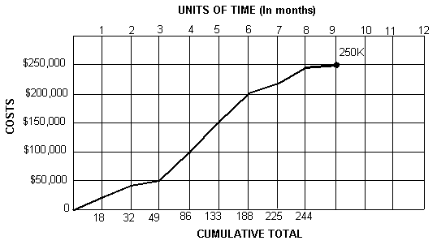

**"People Skills" and Cost Estimating: Ethics Again**

In a situation where there can be skepticism, or even out-and-out mistrust, how do you get your cost estimate accepted by senior managers? I've got two words for you: *honesty* and *consistency.* If you consistently provide realistic estimates, you will gain credibility in your organization. Therefore, my advice is: Don't spend time trying to figure out what "game" other managers may be playing. Concentrate on coming up with the most accurate estimate possible, given the data. Remember you will probably continue to work with some of the same individuals in the future, and it will be better to do so under conditions of mutual trust. It is ethically necessary to be honest in negotiations within an organization, just as it is in negotiations between the organization and an outside party.

**Quality Management Processes: Cost Estimation Checklist**

When you have completed your cost estimates, do you have

* A description of the scope of the work estimated, with a reference to the WBS?
* Documentation for the basis of the estimate?
* An indication of the range of possible results?
* Documentation of assumptions made in completing the estimates?
* Documentation to show that the benefits to the project of each activity is worth its cost?

As a way to test how realistic you believe your estimates are, ask yourself if you would risk senior management disapproval to support your estimates. This is not to suggest that you should go to such lengths on the job, but it is a useful question to test your own feelings about the validity of your estimate